IAM and Access Control in AWS Poorna Chandra Dinesh

**Part 1 – IAM Setup**

**Step 1 – Create IAM Groups**

Created two IAM user groups in AWS — **Admins** with AmazonEC2FullAccess and **Viewers** with AmazonEC2ReadOnlyAccess.

1. Admins

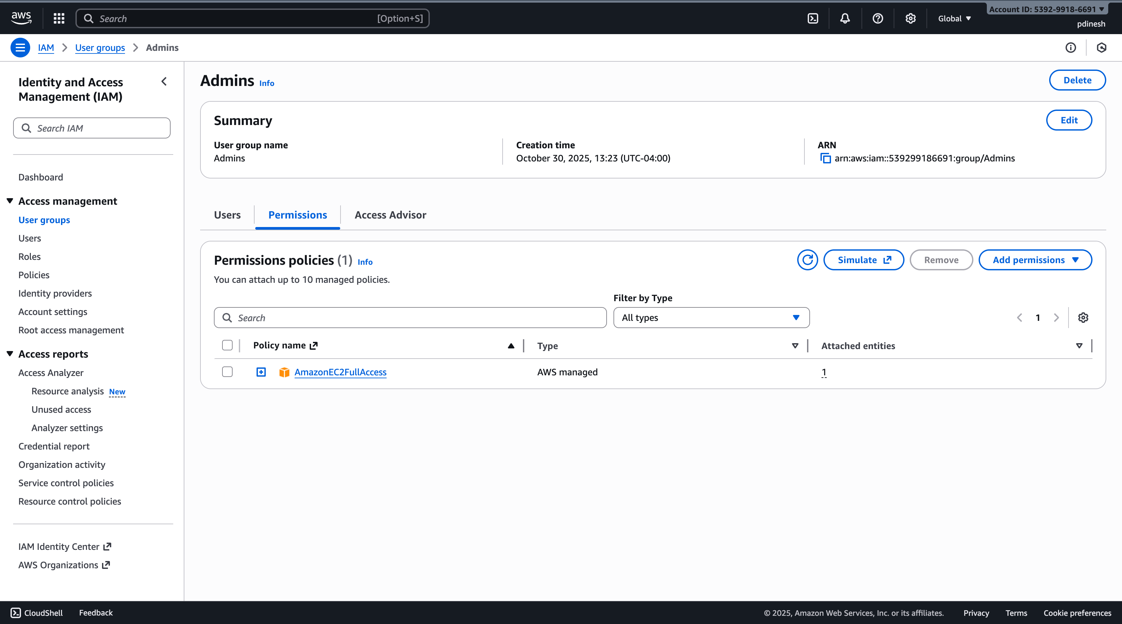

1. Viewers

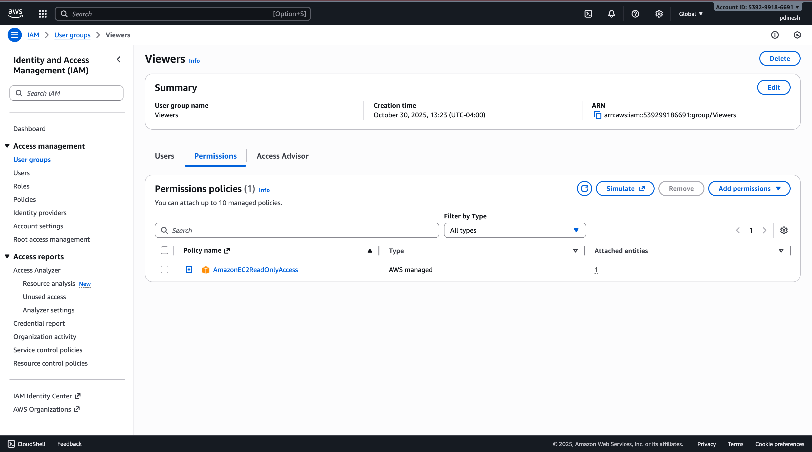

**Step 2 – Create IAM Users**

Created two IAM users (**user-admin** and **user-viewer**) with console access and autogenerated passwords, assigning them to the **Admins** and **Viewers** groups respectively.

1. user-admin

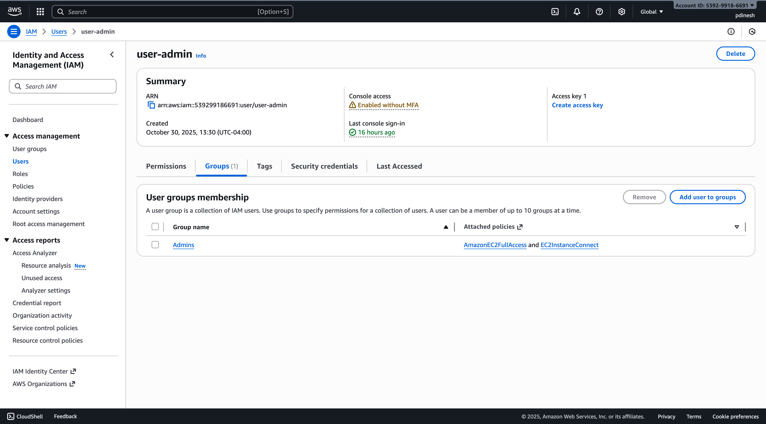

1. user-viewer

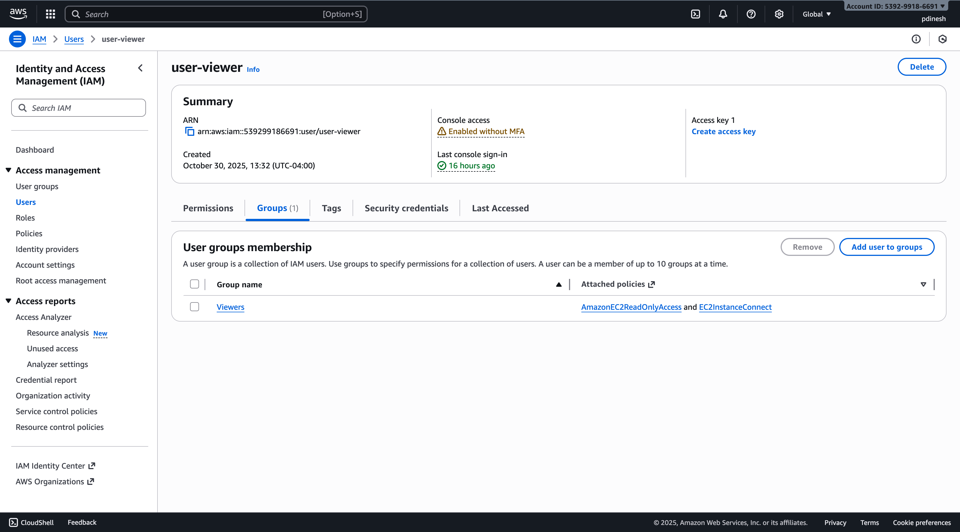

**Step 3 – Add EC2 Connect Permissions**

Attached the **EC2InstanceConnect** policy to both **Admins** and **Viewers** user groups.

1. Admins

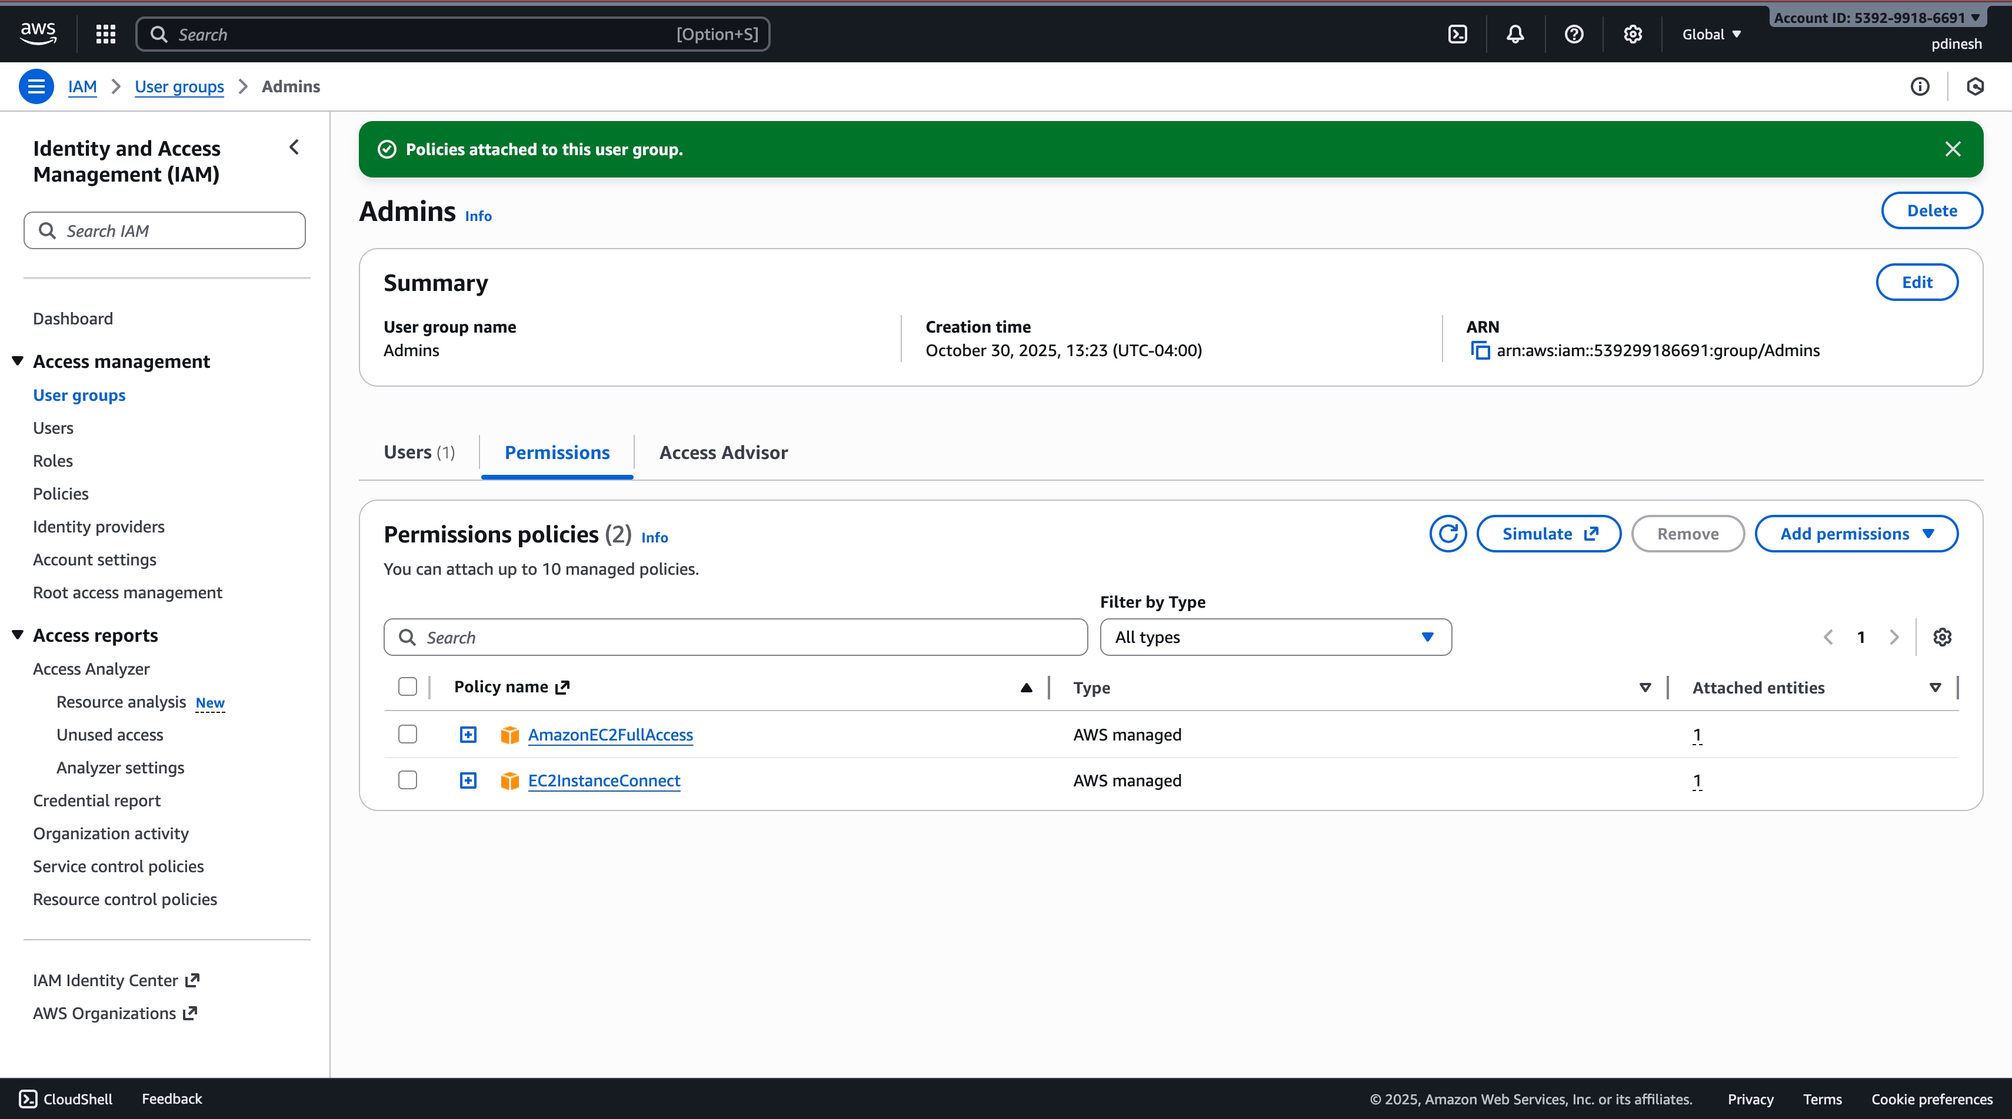

1. Viewers

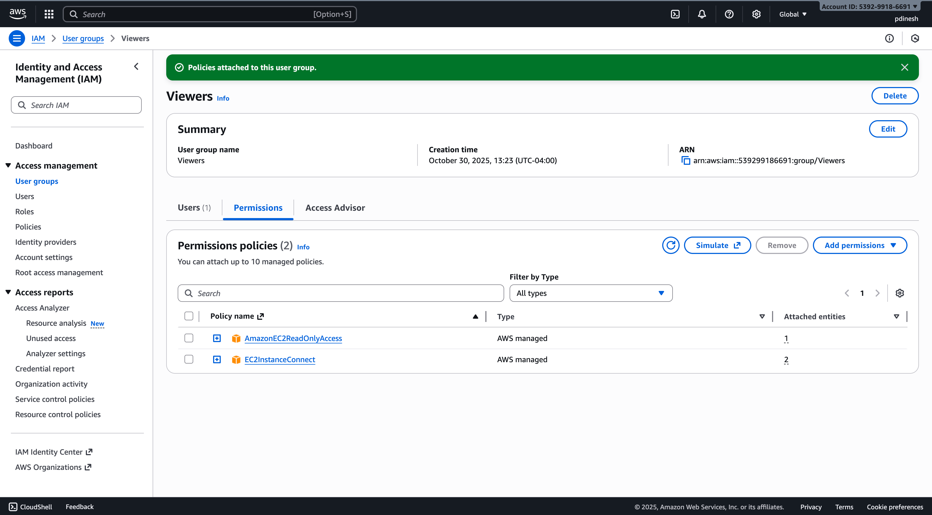

**Step 4 – Test IAM Login**

Created an AWS account alias and verified role-based access by confirming that the admin user could manage EC2 instances while the viewer user had restricted permissions.

1. user-admin

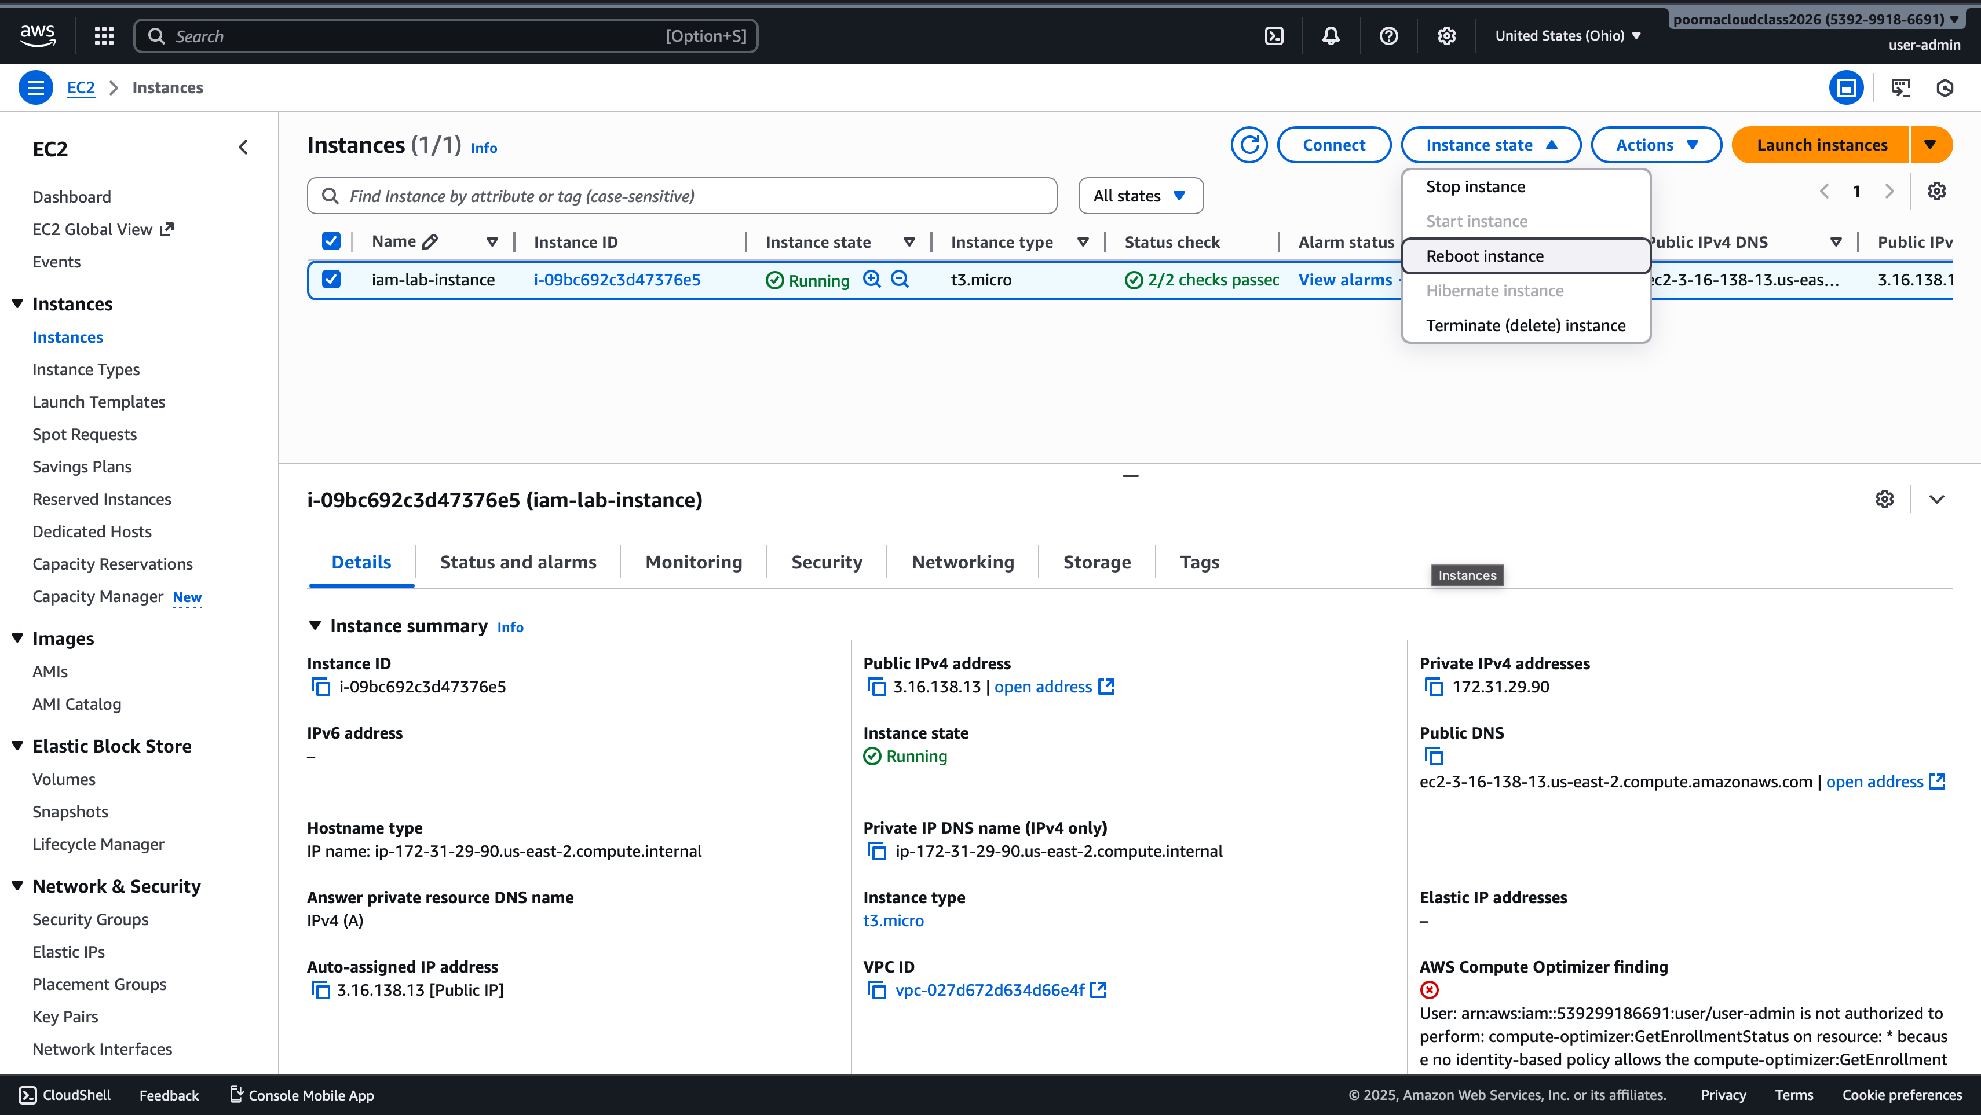

1. user-viewer

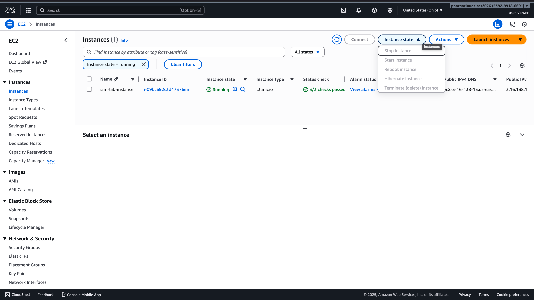

**Part 2 – EC2 Instance and Linux Access Control**

**Step 5 – Launch an EC2 Instance**

Launched a t3.micro Amazon Linux 2023 EC2 instance named iam-lab-instance with 8 GiB storage and SSH access from my IP.

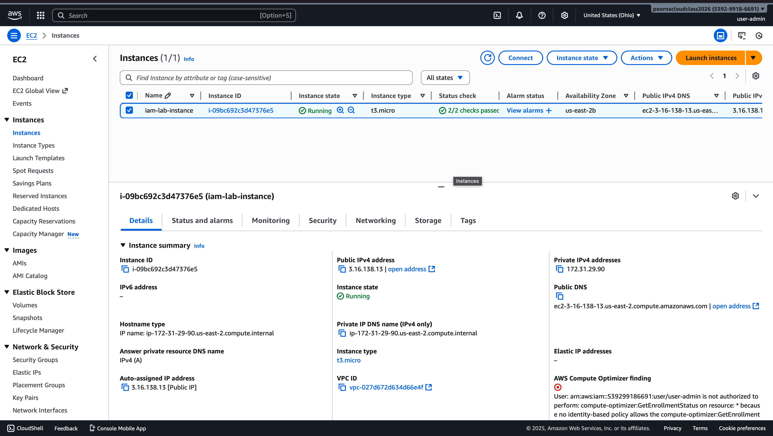

**Step 6 – Connect to the Instance**

Connected to the EC2 instance using EC2 Instance Connect through the browser terminal.

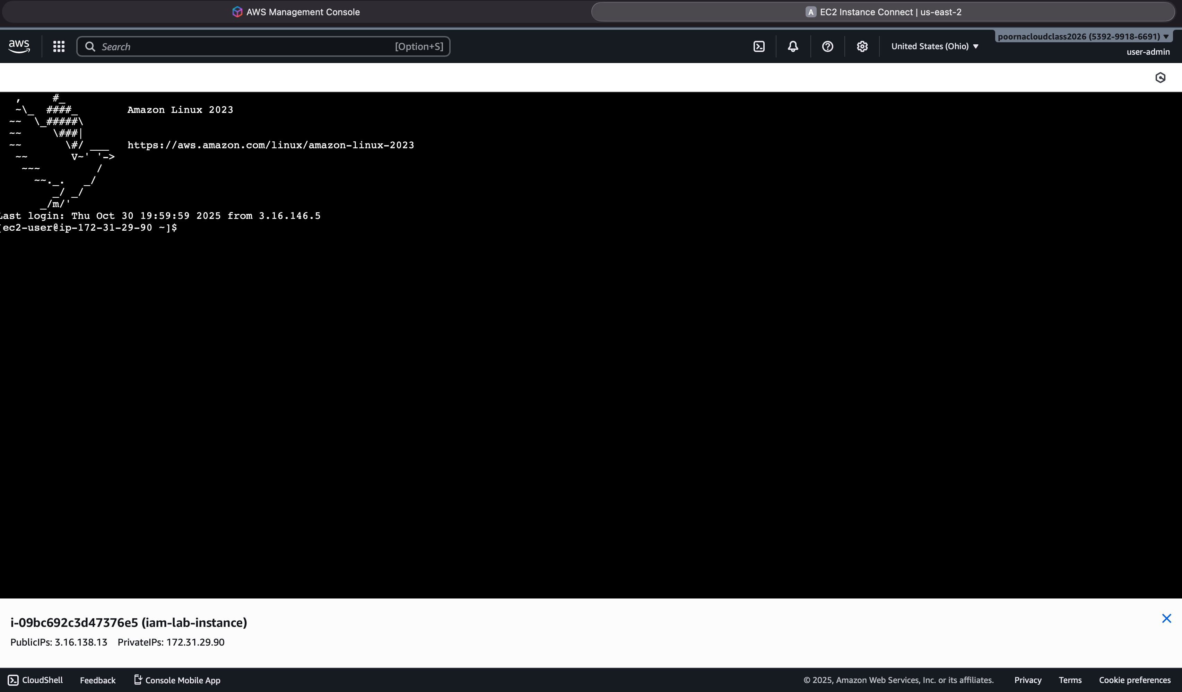

**Step 7 – Create Linux Users and Shared Folder**

Created two users (adminuser and vieweruser) with passwords and set up a shared folder containing a test file for IAM testing.

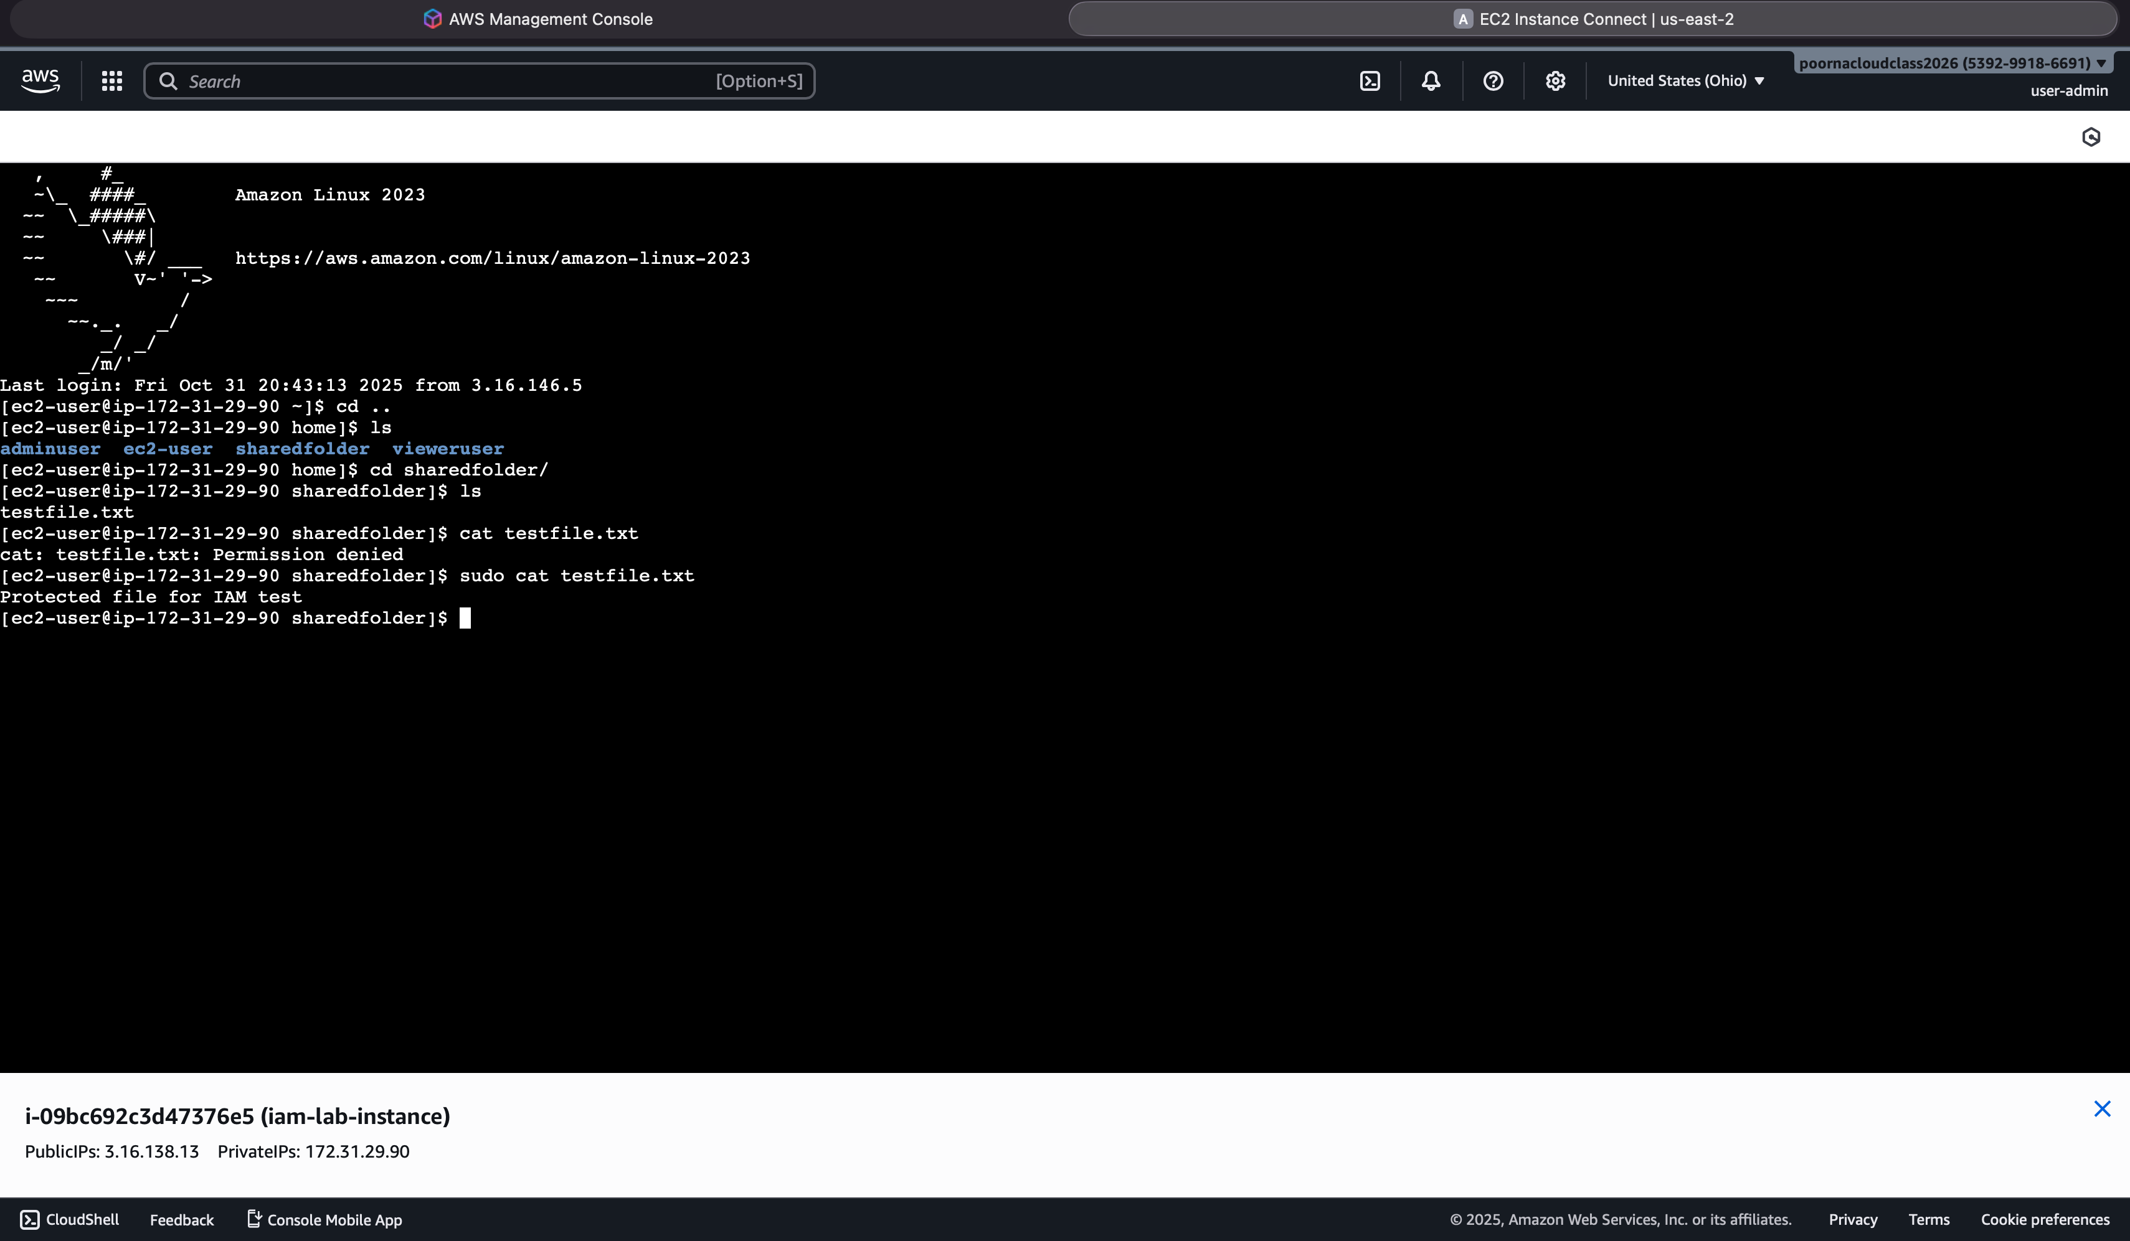

Creation steps below:

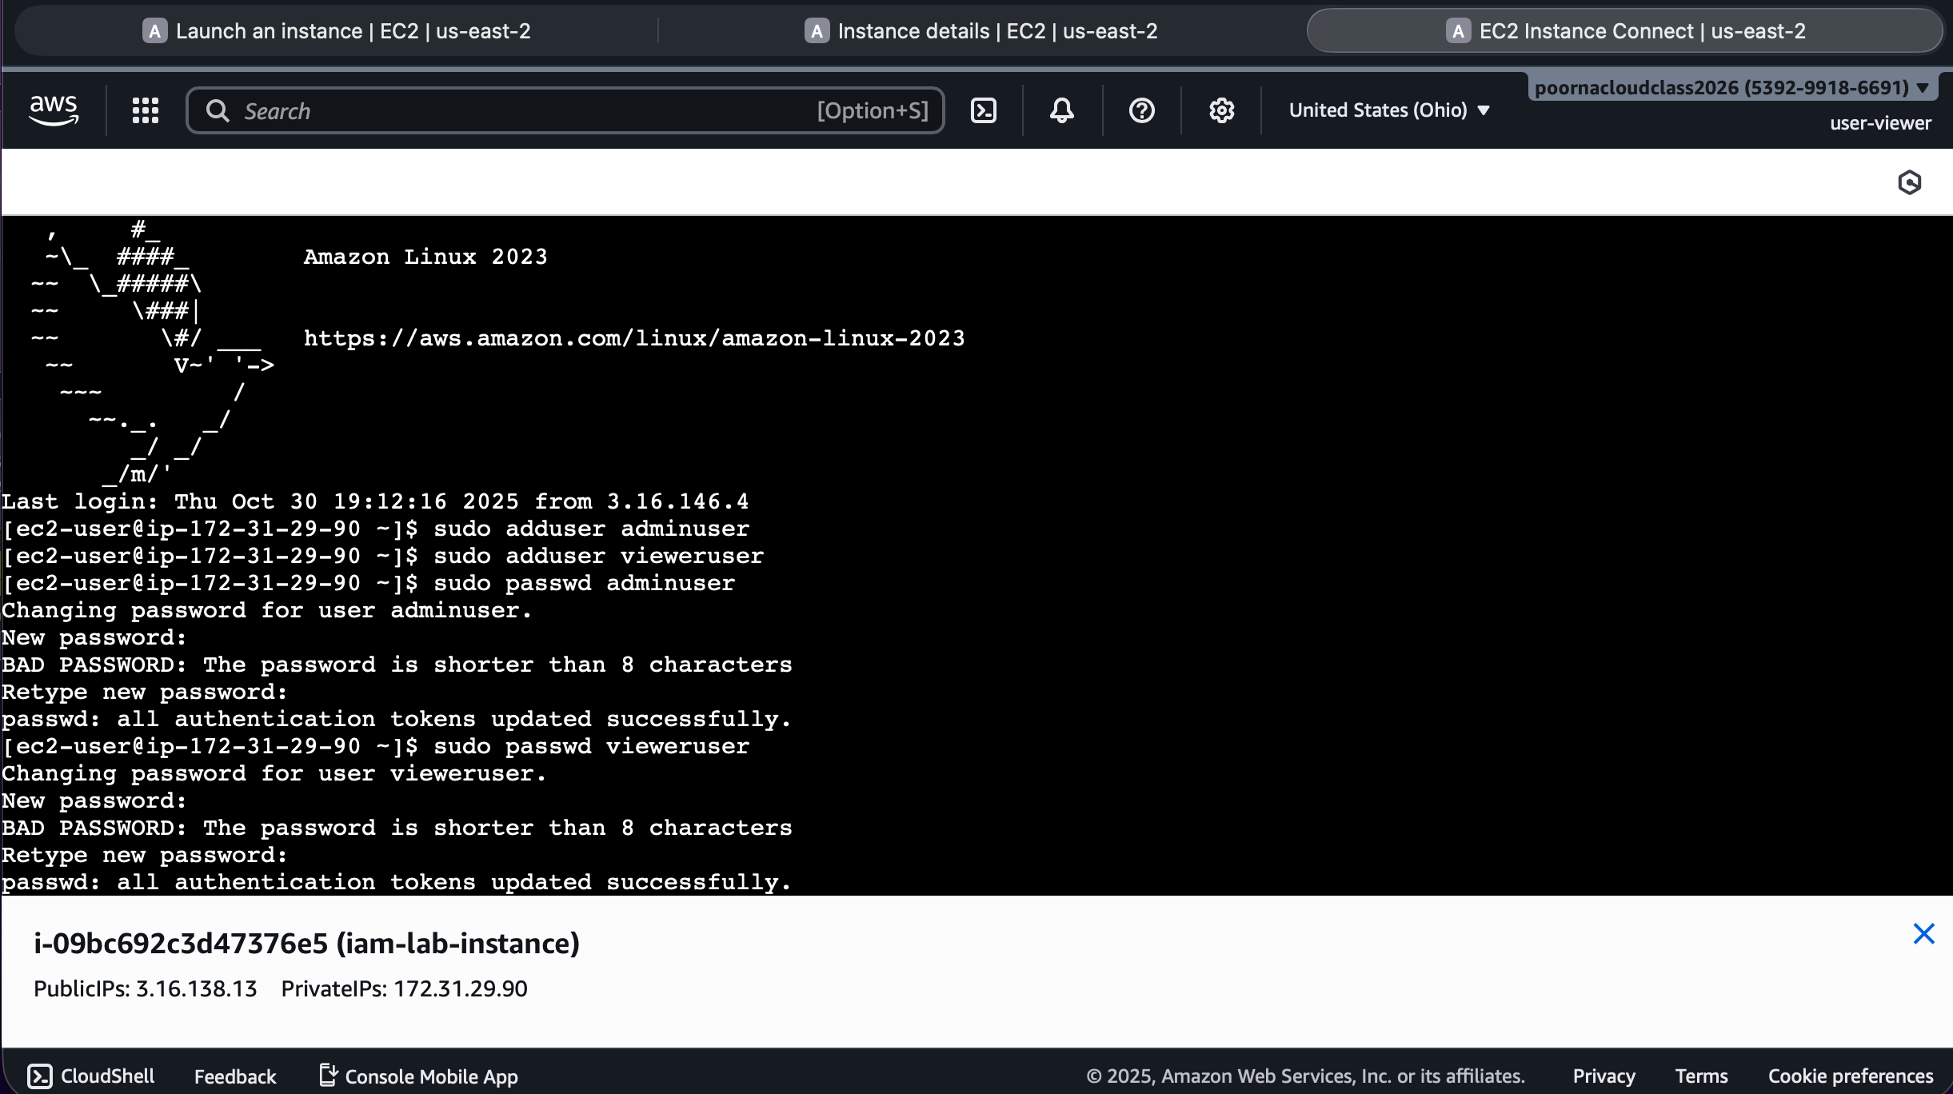

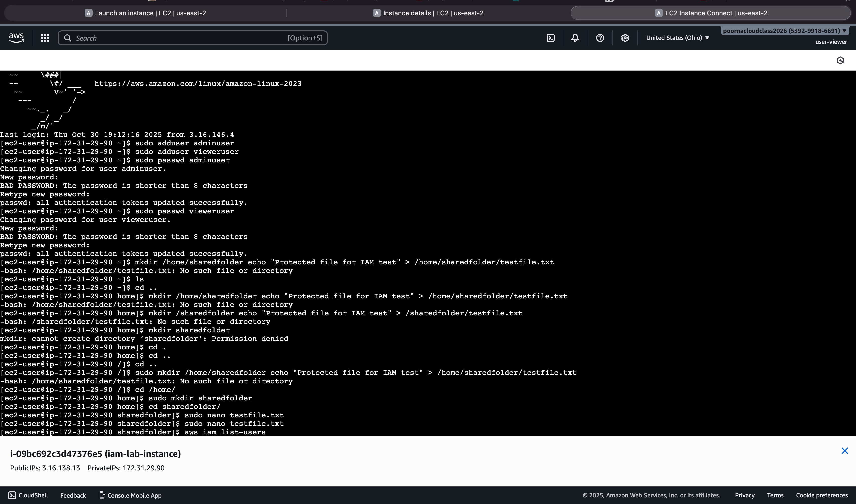

**Step 8 – Set Ownership and Permissions**

Permissions before changing.

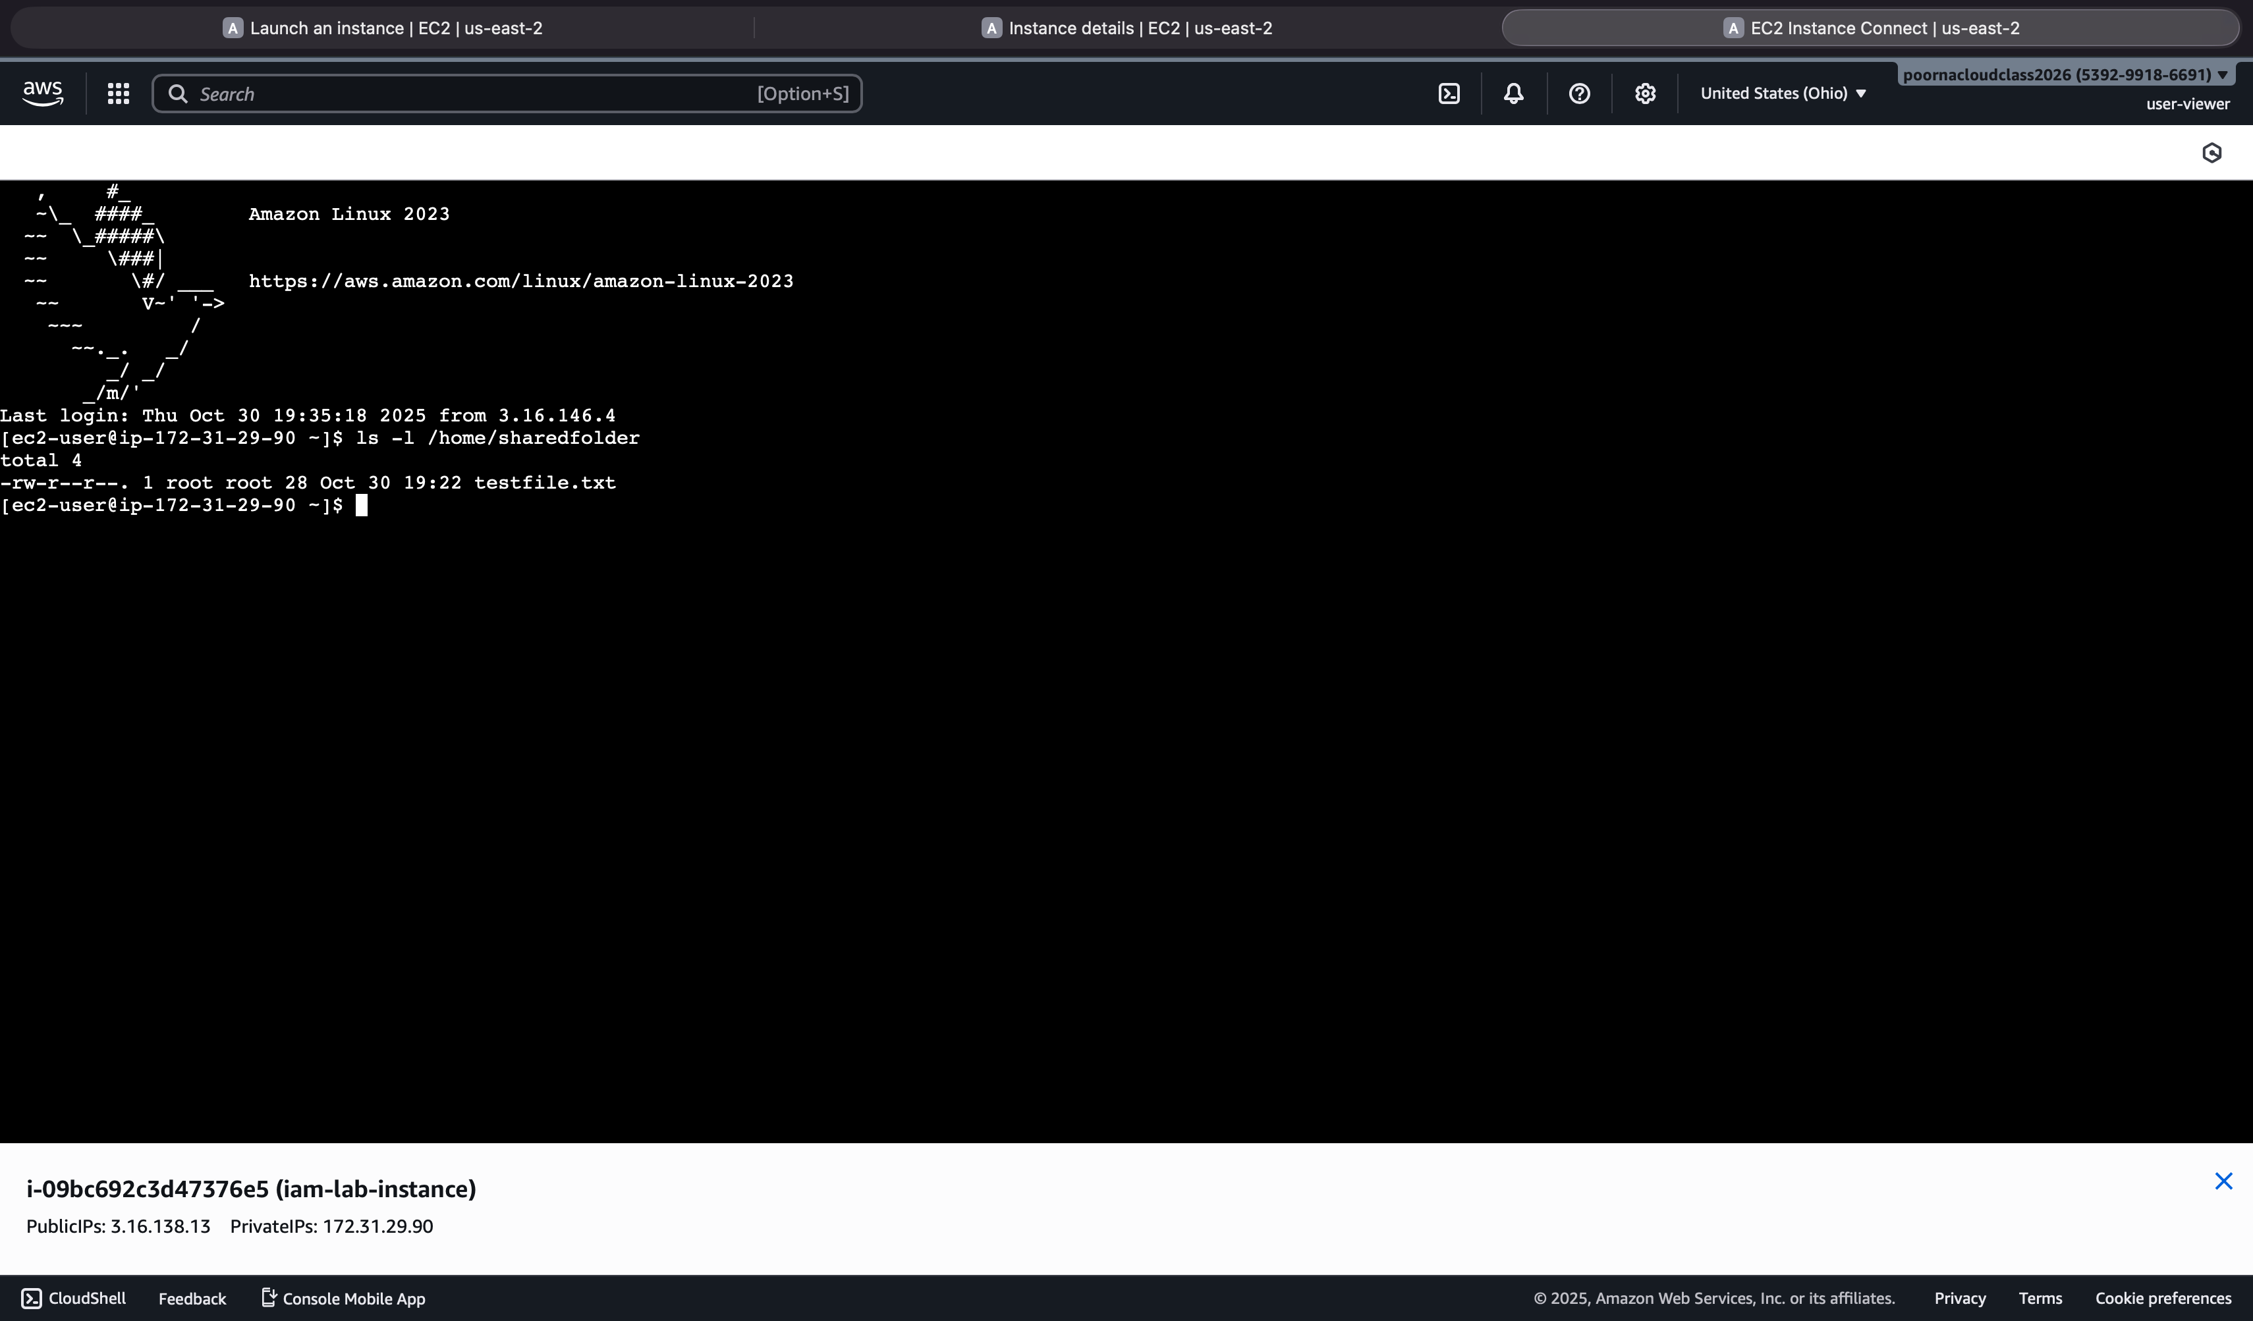

Set ownership of testfile.txt to adminuser and permissions to rw-r----- for proper access control.

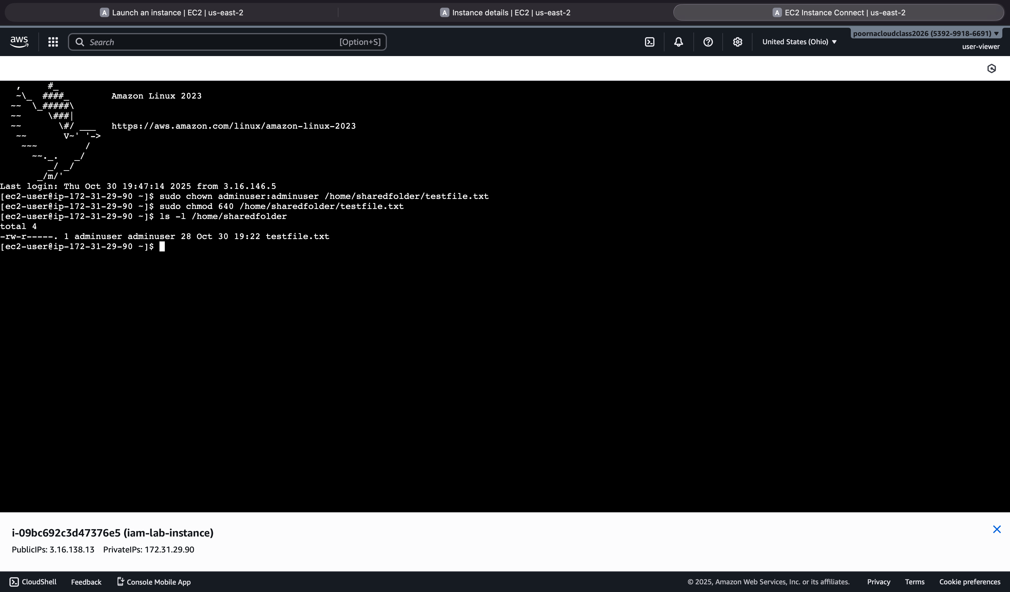

**Step 9 – Test Access**

Tested file write permissions in /home/sharedfolder: adminuser successfully edited testfile.txt, while vieweruser received “Permission denied.

**As adminuser:**

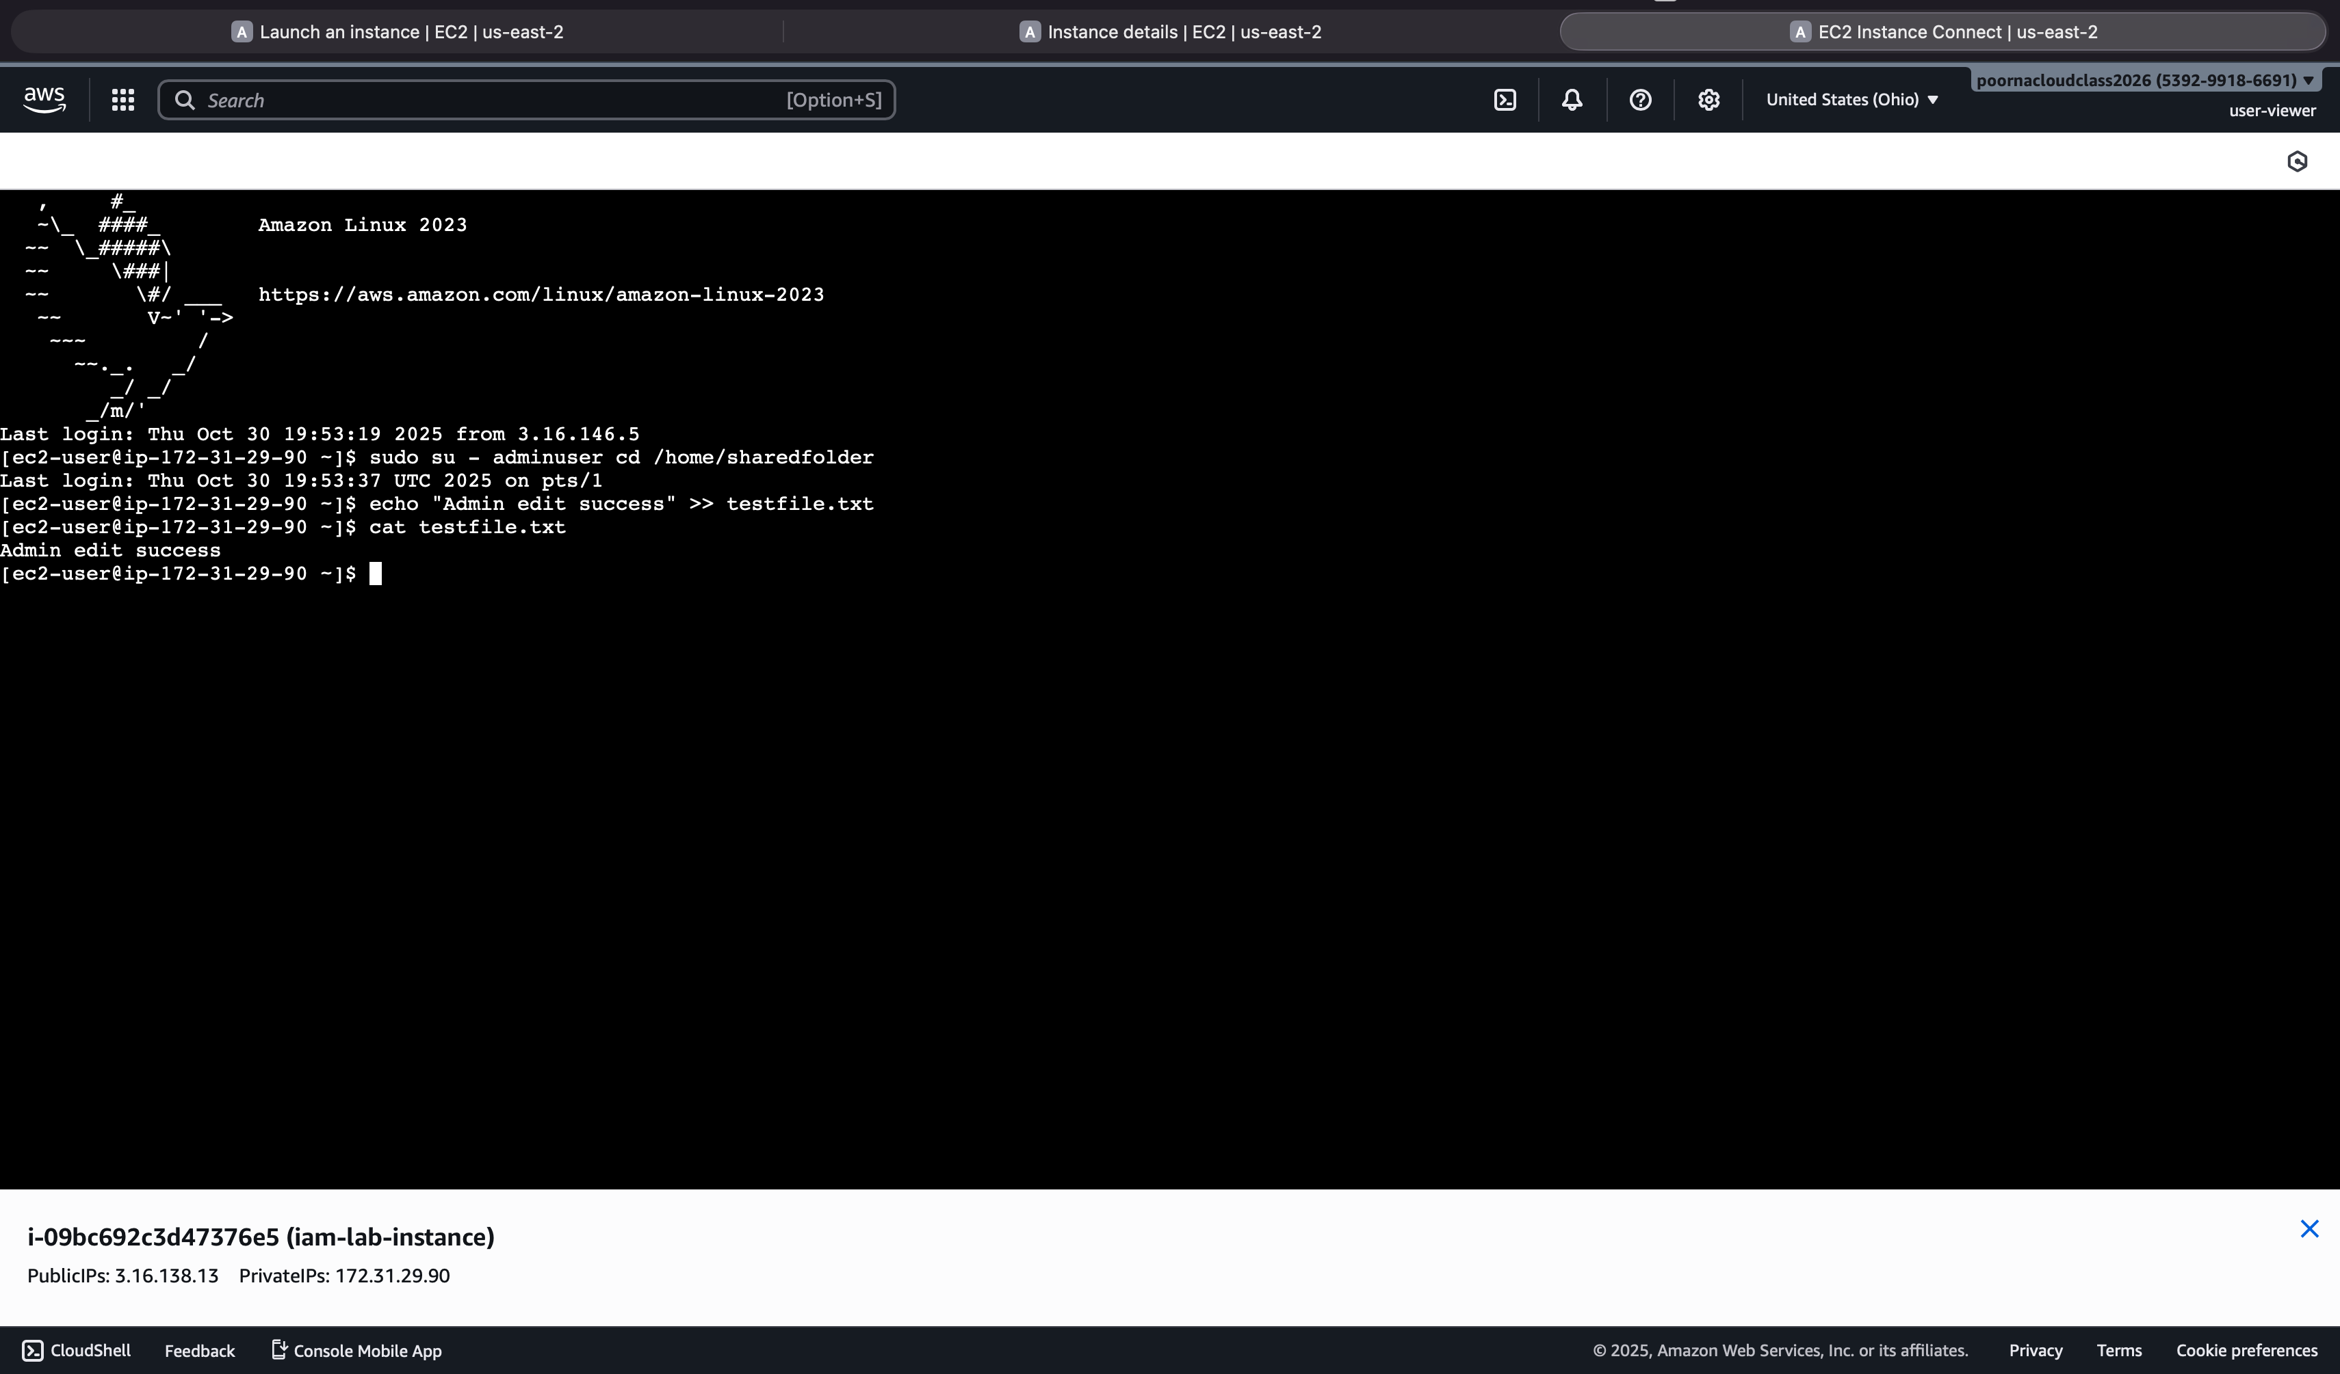

**As vieweruser:**

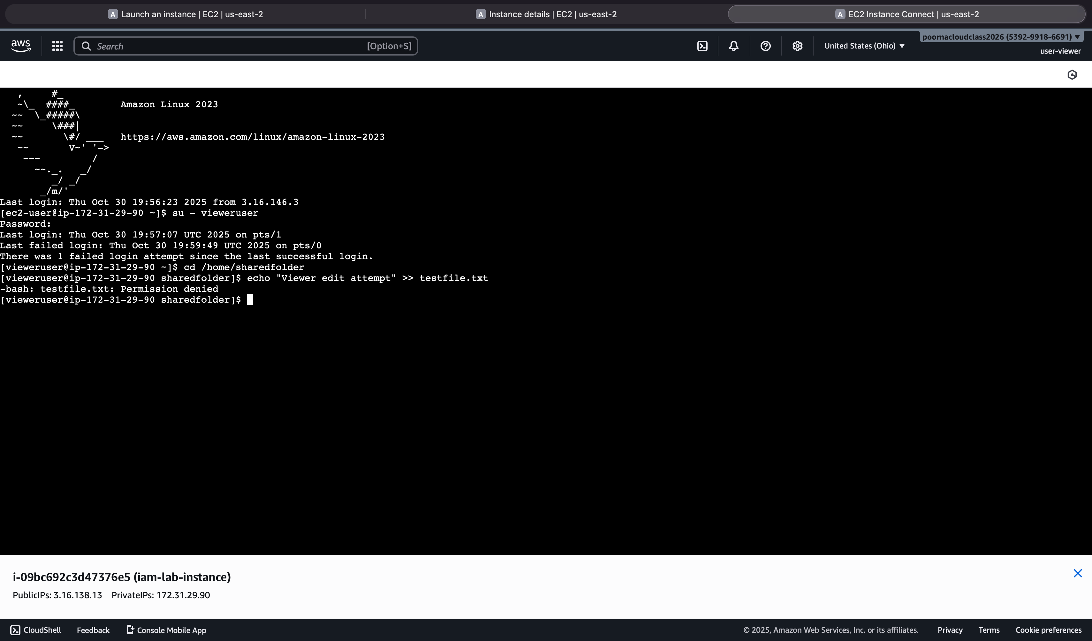

**Part 3 – Custom JSON IAM Policy**

**Step 10 – Create a Custom Policy**

Shows the custom IAM policy JSON with both “Allow” and “Deny” actions defined for S3 operations.

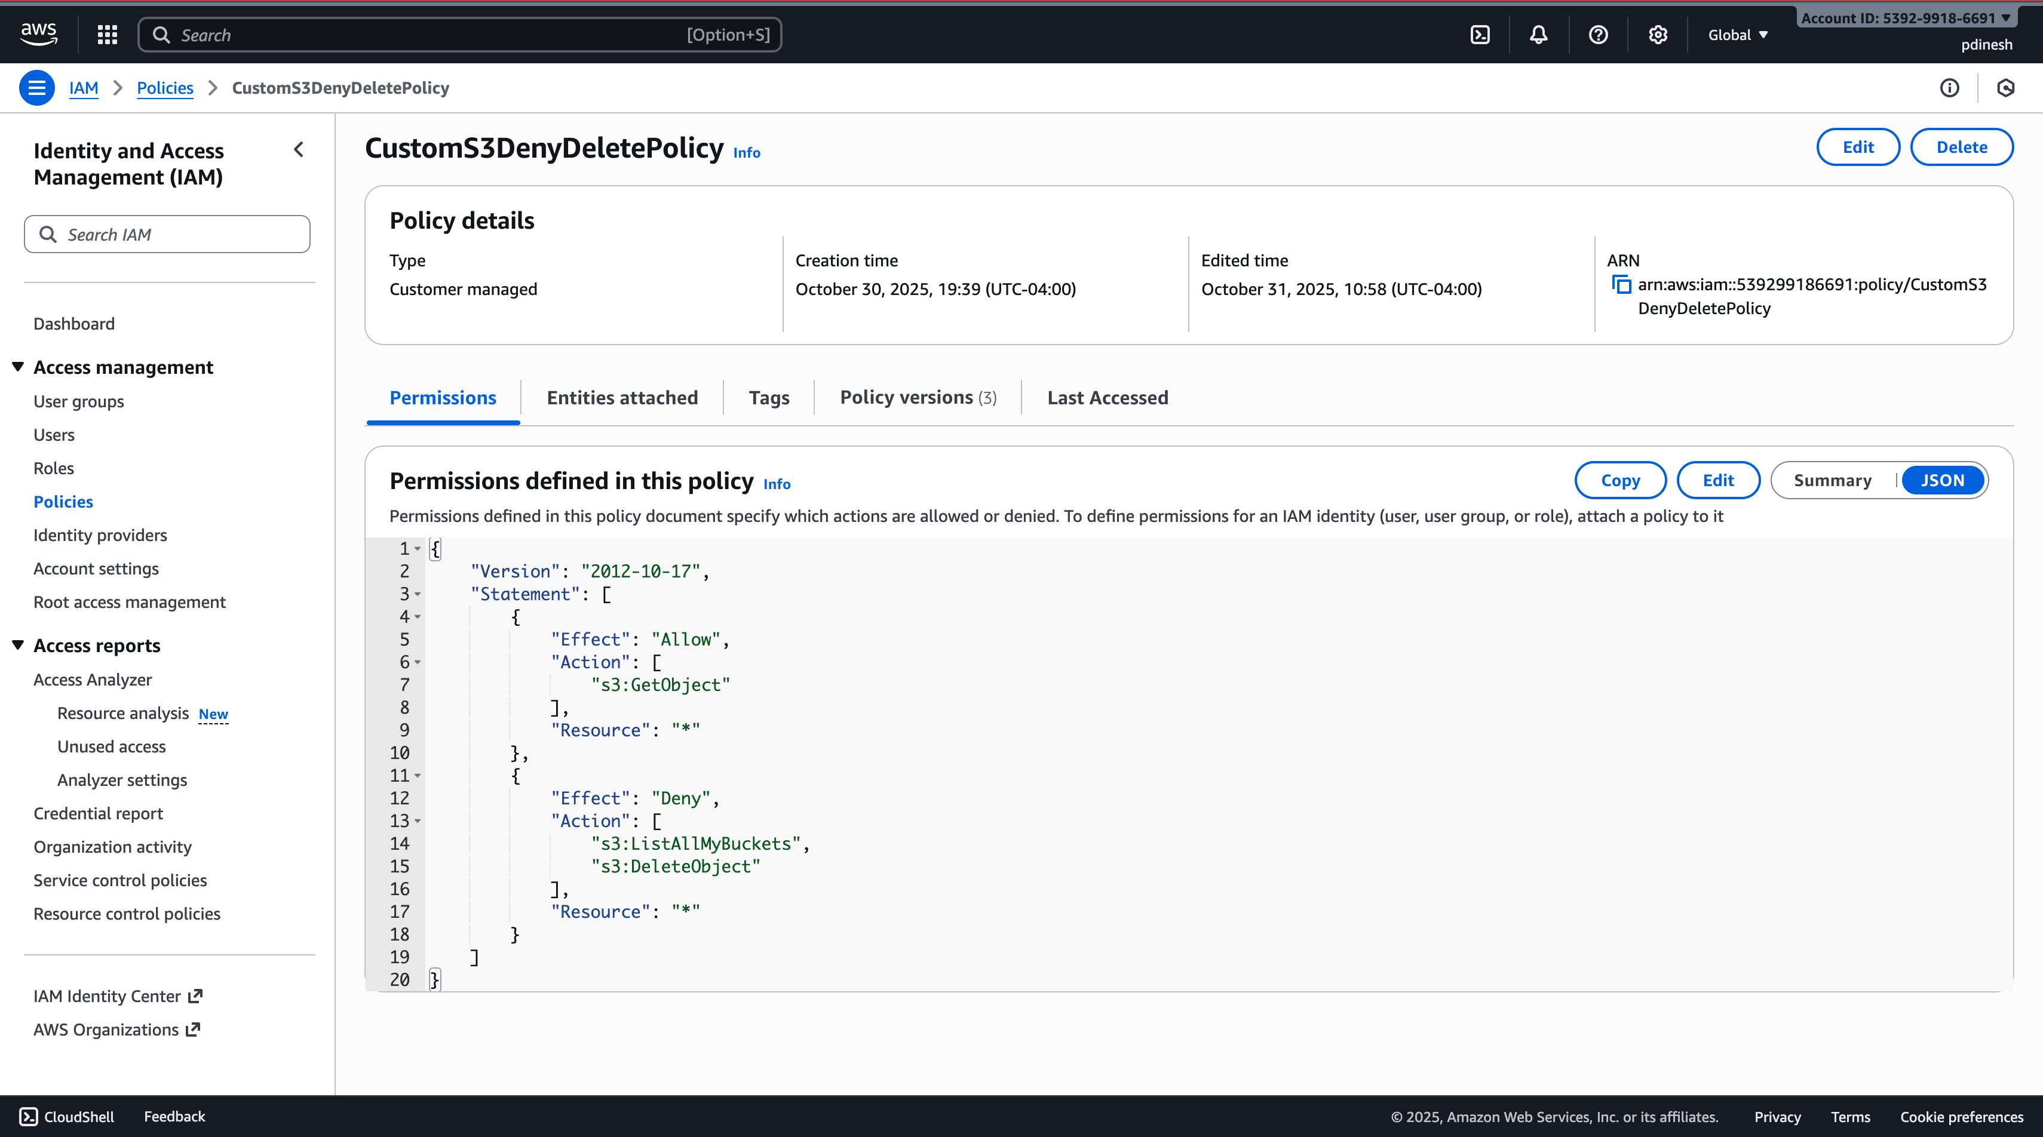

Confirms successful creation of the custom policy (CustomS3DenyDeletePolicy) in IAM.

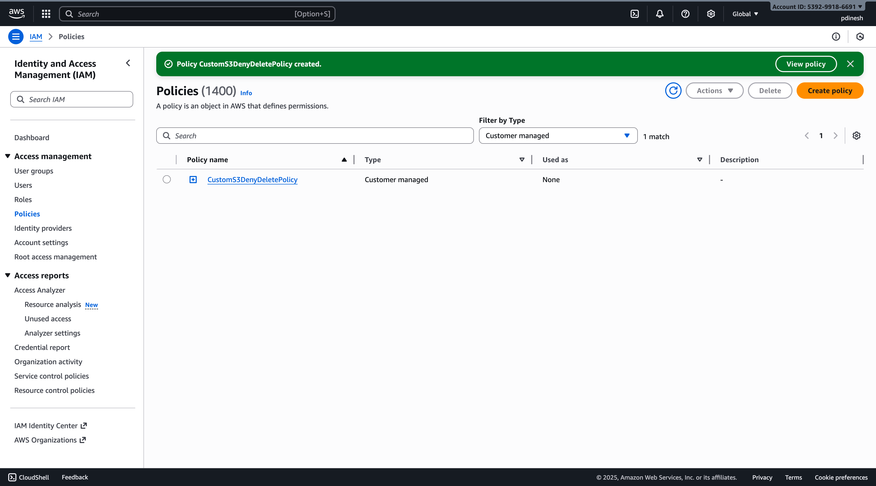

**Step 11 – Attach the Custom Policy**

Displays the IAM user(user-viewer) permissions tab showing the attached custom policy successfully linked.

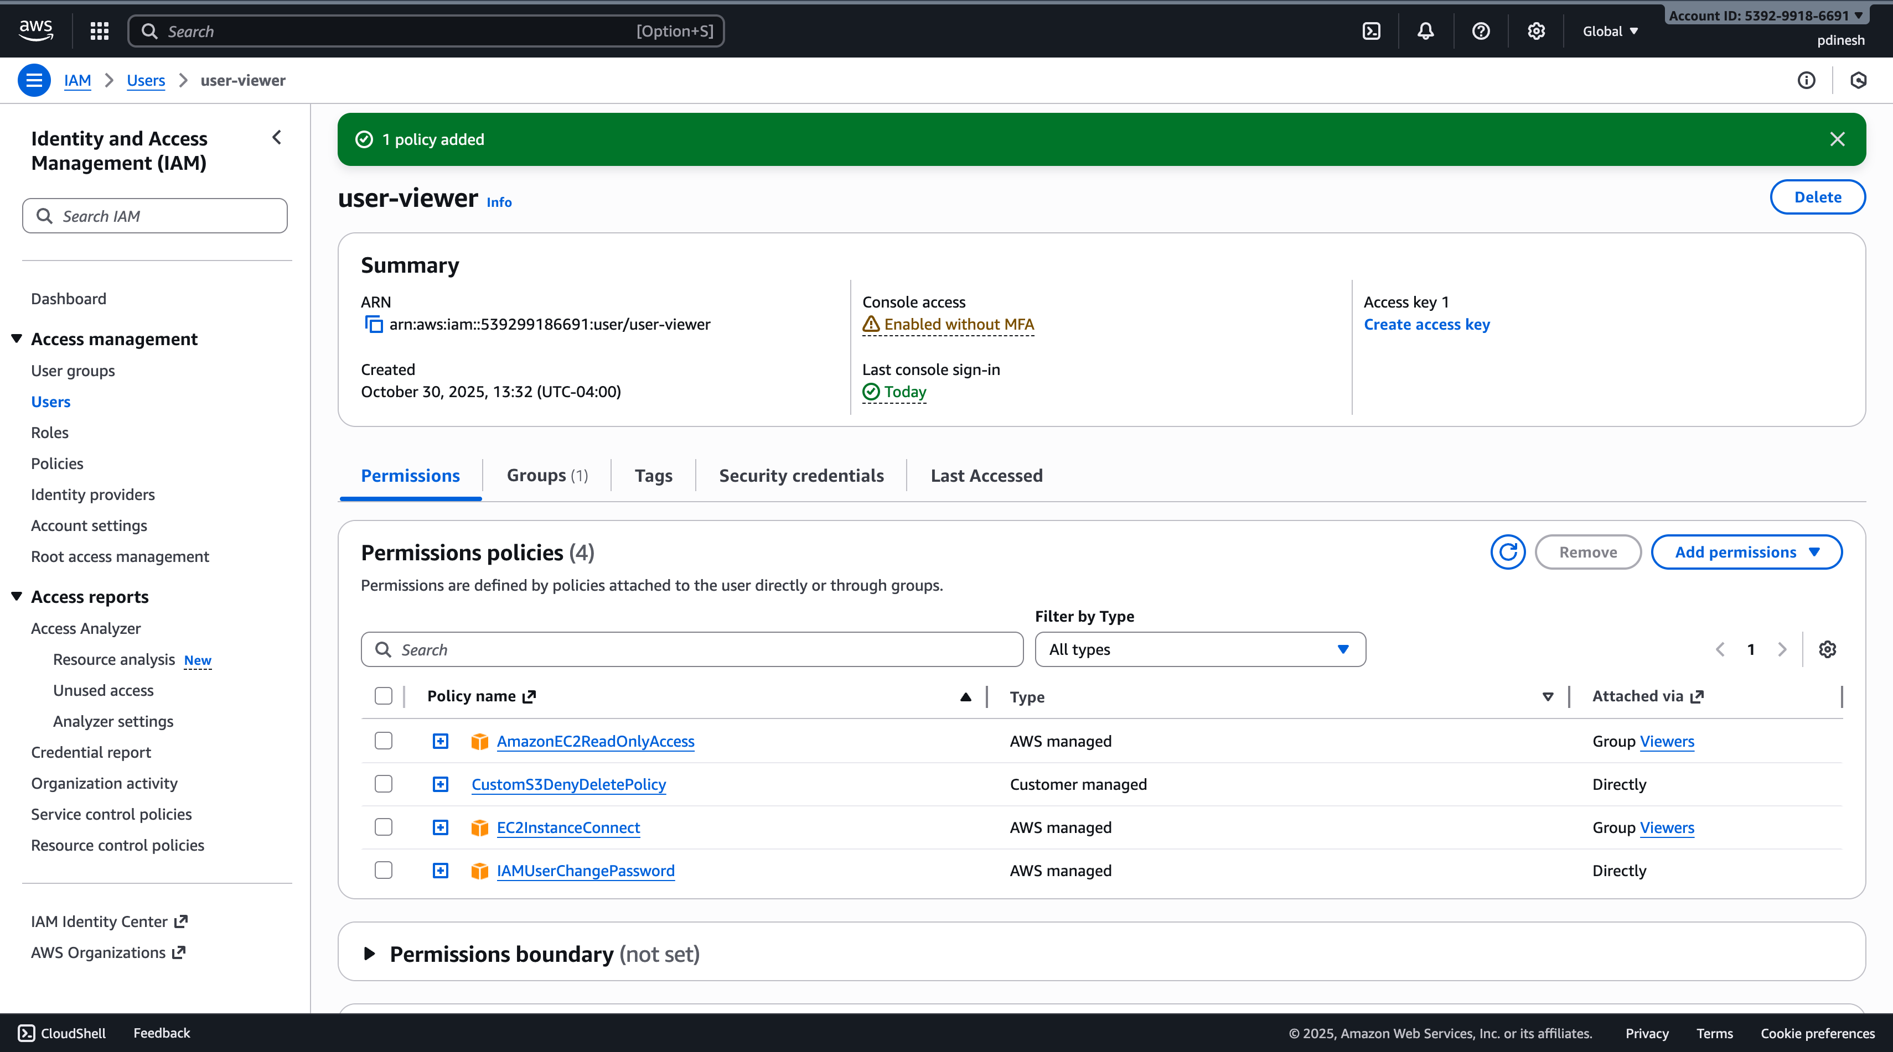

**Step 12 – Test the Policy Twice**

**Test 1: Deny Active**

Demonstrates the IAM policy’s Deny rule in effect, preventing the user from listing S3 buckets.

The listing attempt should fail with **“Access Denied.”**

Access Denied Test.

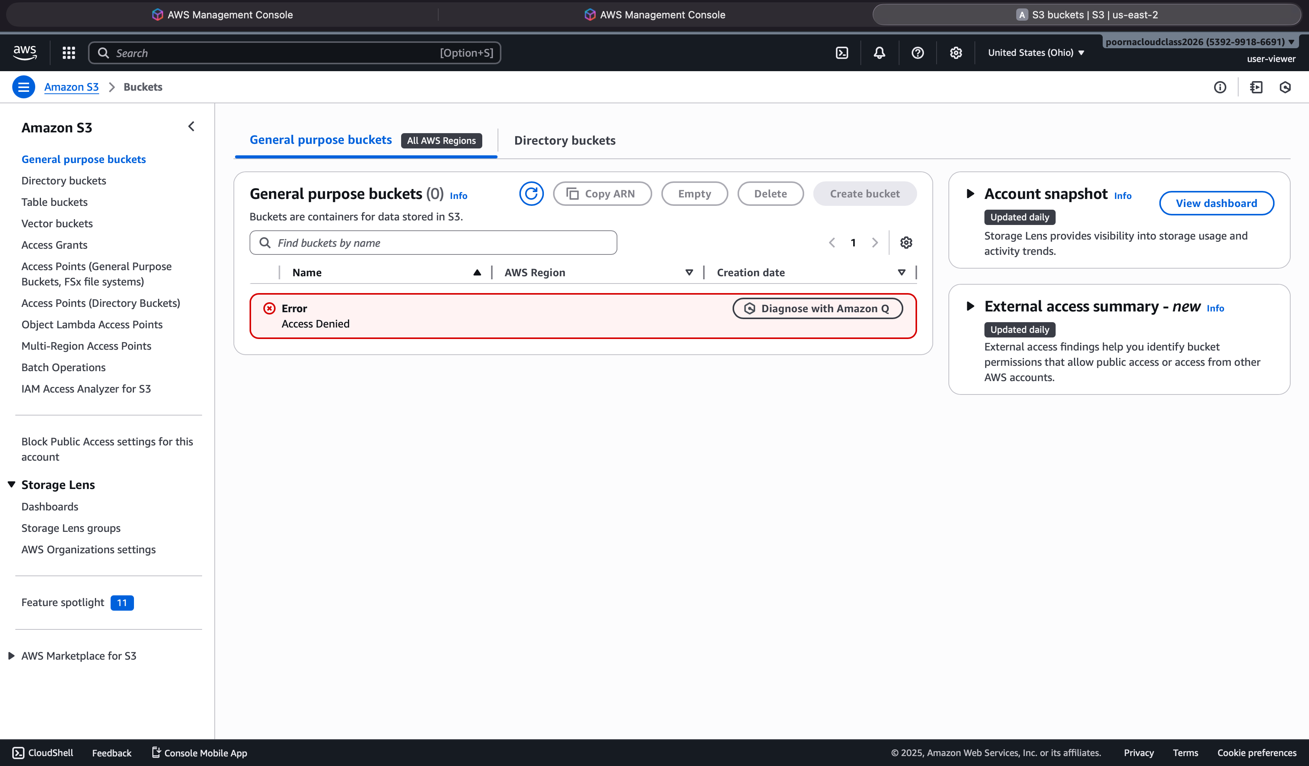

**Test 2: Allow Active**

Change "Effect": "Deny" to "Effect": "Allow"

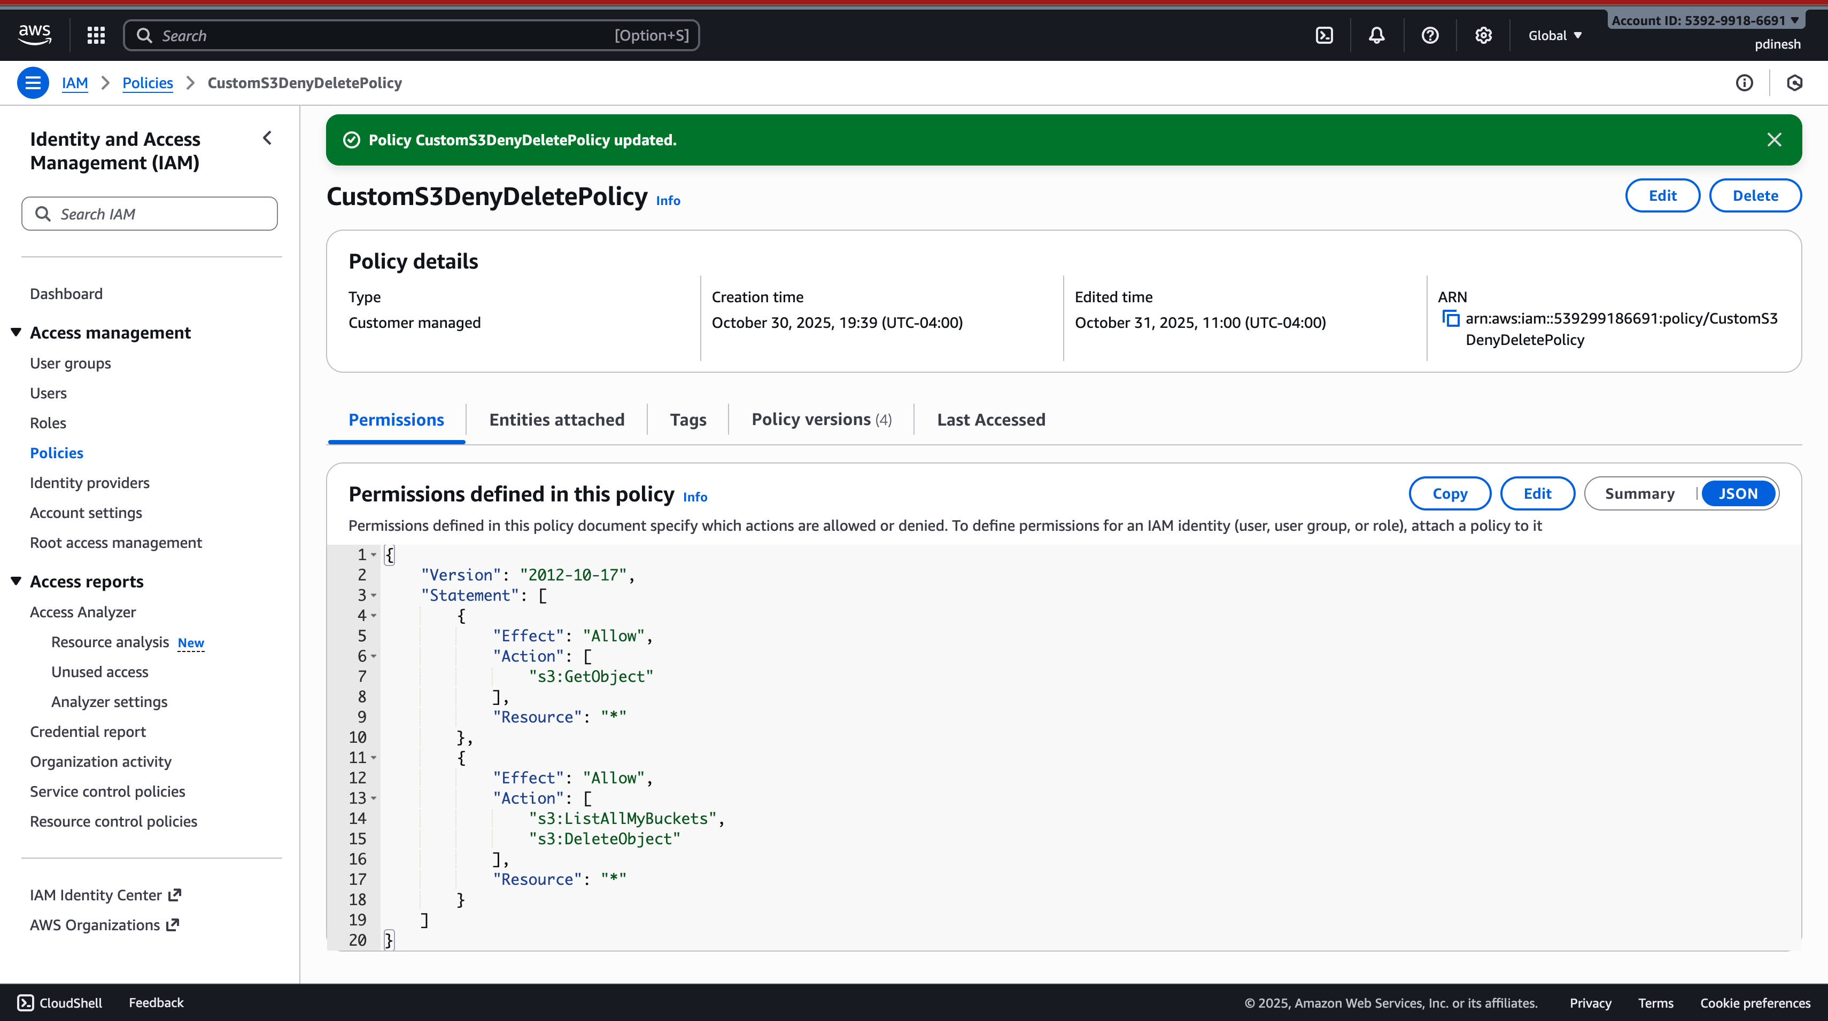

Shows the IAM policy’s Allow rule successfully enabling the user to list all available S3 buckets in the console.

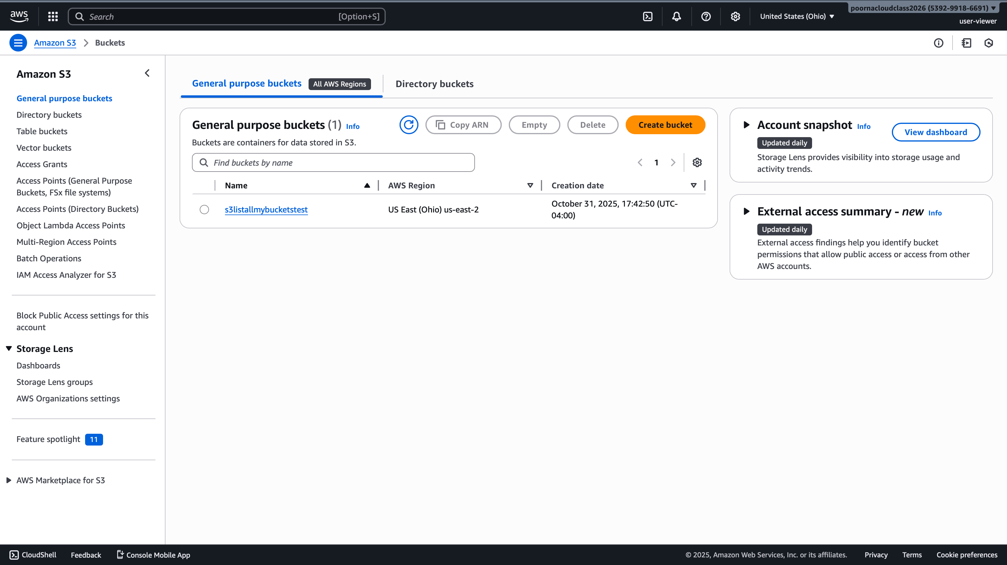

**Part 4 – Summary and Submission**

**Step 13 – Write a Summary**

Through this lab, I gained hands-on experience with AWS Identity and Access Management (IAM) and how permissions control access to cloud resources. I created separate IAM groups and users with different permission levels to observe how access varies between administrators and viewers. After launching an EC2 instance, I connected to it and configured Linux users and file permissions to compare AWS-level security with operating system level control. I also designed and tested a custom JSON IAM policy to understand how the “Allow” and “Deny” statements directly influence user actions. This exercise helped me see how IAM, EC2, and Linux permissions work together to provide layered security and enforce the principle of least privilege in a real cloud environment.